Front End Practical Exercise

Task: Create a working JavaScript stopwatch

Time allowed: 45 minutes

Brief

Create a working JavaScript stopwatch with start, stop and reset functionality. The time format must be hours, minutes and seconds (HH:MM:SS).

No frameworks or libraries have been provided. Please use plain JavaScript only to complete this task.

Basic styling has been provided:

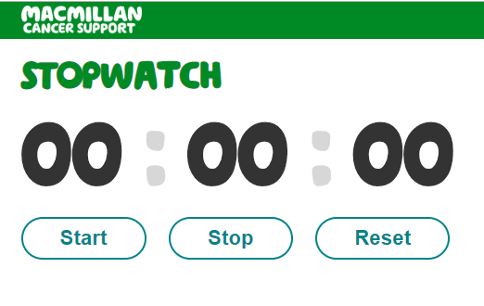
This is primarily a JavaScript exercise but feel free to change the mark up and CSS in ways that will enhance the user experience.

No legacy browser support is required, just Chrome will be fine for this assessment.

This is not an exam conditions exercise and you may use the internet for reference but be prepared to explain your work at the end.

Good luck!

